Wolves SSAGO Into the Wilderness Challenge Badge

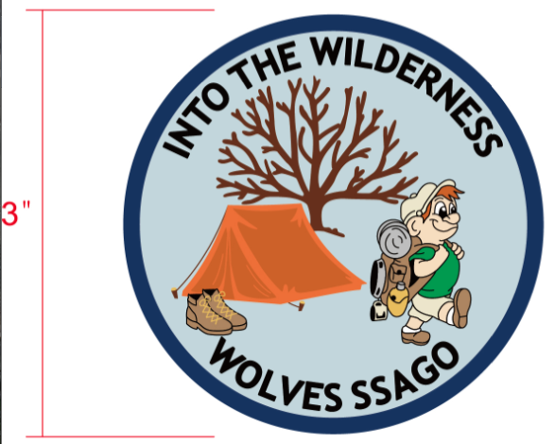

Please note we do not operate as a Girl Guiding/Scouting unit therefore we do not need to include the trefoil or fleur-de-lis on the badge.

Wolves SSAGO Into the Wilderness Challenge Badge

Welcome to Wolverhampton University Scout and Guide Society (Wolves SSAGO). We have created this challenge badge to help raise funds to cover activity costs and to help pay for events we attend with SSAGO, the national Student Scout and Guide Organisation. Between us, we lead and volunteer with units in all sections in both Guiding and Scouting as well as running a weekly session for our members which are students at the University of Wolverhampton.

This challenge badge is designed to focus on the great outdoors. It has been split into 3 sections focusing on: Before you go into the Wilderness, The Wilderness and Wilderness SOS.

We have organised the challenge according to the sections mentioned above. Some of the challenges are best suited to different age groups. It is at the discretion of the leaders to assess which challenges will be most appropriate.

We have tried to make this challenge suitable for all ages and abilities! We suggest that groups complete the following:

Rainbows/Beavers - at least 1 challenge from each section.
Brownies/Cubs - at least 1 challenge from each section, plus 2 more from any section.
Guides/Scouts - at least 1 challenge from each section, plus 3 more from any section.
Rangers/Explorers - at least 1 challenge from each section, plus 4 more from any section.
If you have any question feel free to email wolverhamptonssago@gmail.com
Badge order form
Name
Unit
Address

Postcode

Contact details (Email or Telephone)

I wish to order badges at £1.50 each Total £

Postage:
1 – 30 badges = £1.50
31-100 badges = £2.50
101 – 200 badges = £3.50
Total Payment:

Please email this form to wolverhamptonssago@gmail.com
and we will contact you regarding payment.
Before you go into the Wilderness
This section is all about being prepared before you take part in an outdoor activity as well as crafts and activities to acquire and develop skills, which can be used in the wilderness.
1.Equipment
- Discuss with your group what equipment the group would bring on an over night trip and why it is important.
- Hide names of different equipment, which your group uses around the room, and ask the group to find them and to show you/take a photo of that piece of equipment. See if they can match them all up correctly.
2. Clothing
- Talk about how you wear different clothes in the summer and winter. Get your group to create clothes for a doll/cut out of a person for the summer and winter. If you wish you could do a fashion show.
  - Have a look at this website with useful information about the layering of clothes for the winter: http://www.gooutdoors.co.uk/expert-advice/layering-system-guide
3. Map Reading
- With your group learn how to use a compass and read a map. Be able to identify what some of the different symbols on a map mean. Appendix 1 has a guide to the parts of a compass and here is a video demonstrating how to take a bearing https://www.youtube.com/watch?v=rZd0RfsC-9I
OR
- Using a map and a route card plan a 5 kilometre hike starting and finishing at a point determined by your leader. There is a blank route card in appendix 1.

4. Camp planning
- Organise a camp for your group. Remember you need to include activities and a menu with instruction on how you cook each meal. You could always use this plan for your next camp.
5. Knot skills
- Learn different types of knots with your group and make a paracord bracelet. See who can tie different knots the quickest. Here is a video explaining how to make a pararcord bracelet https://www.youtube.com/watch?v=UKSGg2IuCLI

The Wilderness
This section is all about being in the outdoors, whether this be activities outside or spending a weekend camping
1.Camping
- Go camping with your group and identify the following key locations at a camp site
  - Fire assembly point
  - Water point
  - Fire circle
  - Toilet block
  - 4 other key locations determined by your leader this could include locations where different activities are taking place.
You could create a scavenger hunt with clues to each location.
OR
- Demonstrate you know how to erect and put away a tent. Make sure you let your leader know what you have to do with a tent after camp.
2. Backwards cooking
- Cook a 2 course meal on an open fire. Two of our favourite snacks to cook on an open fire are banana boats and egg in a potato. See appendix 3 for these recipes.
OR
- Collect kindling and wood to make a campfire. Light the campfire using a tepee approach. Please remember if you are using axes to chop wood you need adult supervision.
OR
- Make a cardboard box oven and use this to cook simple foods, such as pitta bread pizza. Detailed instructions are provided in Appendix 3.

3. Nature
- With your group go on a walk/hike for at least 2 miles in the country side/woodland.
OR
- Collect at least 10 objects from outside and identify where they have come from. Using these collected items make a picture that represents the outdoors.
4. Adventure
- Take part in a new outdoor activity. What about trying caving or rock climbing?
OR
- Play a wide game outside in the dark with your group. For the older groups why don't you lead a wide game for a younger section?
5. The sky
- Learn about the different types of clouds and why there are different types. Using cotton wool, create a picture representing the different clouds. A diagram of the different types of clouds can be found in appendix 4.
OR
- Using a tin can, drill holes in the bottom to represent different star constellations. In a dark room shine a torch through the can and see if your group can correctly identify which constellations you have made. There are examples of different star constellations in appendix 4 and a step by step guide to making these tins can be found here http://campfire.andycamper.com/12-days-of-christmas-activity-4-star-gazing

Wilderness SOS
This section is all about what happens if you are in danger and are in need of help when you are in the wilderness.
1.Signalling
- Using Morse code and semaphore to create a message. See if another group can work out what you are saying. Try and have a conversation with another group by one using Morse code and the other semaphore. Refer to appendix 5 for details on Morse code and semaphore.
2. First Aid
- No matter how careful you are injuries are likely to happen. Learn the contents of a first aid kit and role play with your group how you would treat 3 of the following:
  - Burns
  - Broken arm
  - Heat stroke
  - Hypothermia
  - Chocking
  - Unconscious
3. Food health and hygiene
- With your group take part in a food health and hygiene quiz. There is a quiz in appendix 6 you may want to use/adapt. You could make it into a game e.g. one end of the hall is false the other true, or false is sitting true is lying down.
4. Emergency services
- Talk about the different emergency services and how their roles are different (police, ambulance and fire). Practice with your group what you say if you had to dial 999. You might even be able to visit your local police or fire station. Create a poster, which has a list of all the local emergency services and how to contact them. Include any services, which you think are useful to your group such as a local campsite.
Appendix 1-Map reading
Parts of a compass
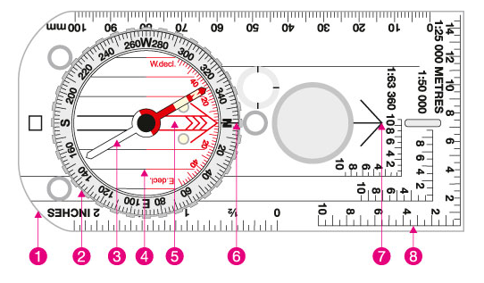
1. Base plate: this is what the compass is mounted on and has rulers and scales on it to help you measure distance.
2. Compass housing: within the rotating bezel there is the magnetic needle. Around the bezel are marked 360° of a circle – these will give you your bearing.
3. Compass needle: The red end always points to magnetic north.
4. Orienting lines: they are fixed within the compass housing and can be aligned with the easting lines on your map to ensure you accurately align the compass with grid north.
5. Orienting arrow: When you come to take your bearing – you will align the compass needle with this arrow.
6. Index line: It is at this mark that you take your compass bearing.
7. Direction of travel arrow: This is the direction in which you will be traveling in after taking your bearing.
8. Compass scales or romer scales: these can help you measure distance and accurately help you work out your six-figure grid reference.

Route card
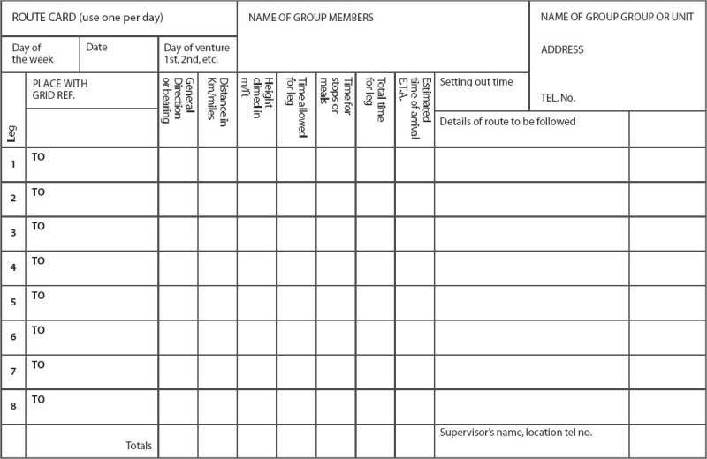
Appendix 2-Knot skills
Different type of knots
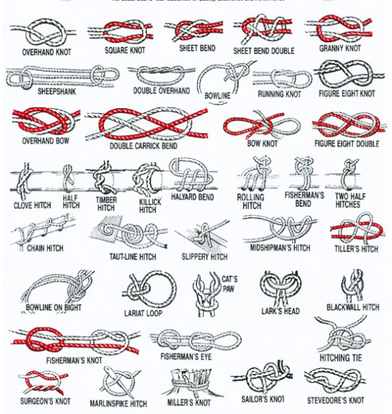

Appendix 3-Backwards cooking
Banana boat
Ingredients
-Banana
-Chocolate buttons
-Marshmallows
-Tinfoil
Method
- With the skin still on the banana cut the banana in half lengthways.
- Place chocolate buttons and marshmallows in the banana and place the two half back together.
- Wrap the banana in tinfoil and place in the embers of a fire.
- Leave for about 5-10 minutes and then enjoy.

Egg in a potato
Ingredients
-Potato
-Egg
Method
- Cut the top of a potato off. Make sure you keep this part.
- Using a spoon hollow out the middle of the potato.
- Crack an egg into the hollow potato and put the top of the potato back on.
- Wrap the potato in tinfoil and place it in a fire.
- Leave for about 15 minutes or until the egg is cooked and then enjoy.
TIP: Use the potato’s you hollowed out to make mash.

Cardboard box oven
What you will need
-Open fire or disposable BBQ
-Large cardboard box and a sheet of card to make a lid to cover the size of the box
-Tin foil
-Scissors or a knife
-4 Metal tent pegs or metal skewers
-Metal cooling rack
-Oven gloves
Method
- If your box has top and bottom flaps cut them off.
- Cover your box and card with tinfoil. There should be no cardboard showing as this is a fire hazard.
- Push 1 tent peg through the side of the box about 3 cm from each corner, half way up the box. Place your cooling rack on the pegs.
- Place your box over an open fire/disposal BBQ. Please note the fire should not be lit at this stage.
- Light the BBQ or open fire
- Once hot cook your chosen meal in your oven by placing the dish onto the rack and placing the cardboard lid over the top to keep the heat in
- Enjoy your meal

Appendix 4-The Sky
Types of clouds
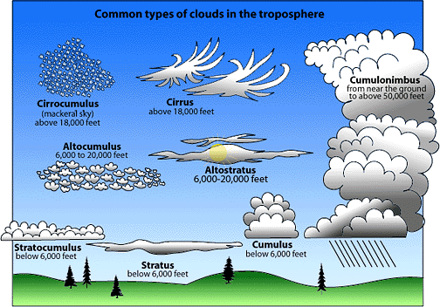

Star constellations
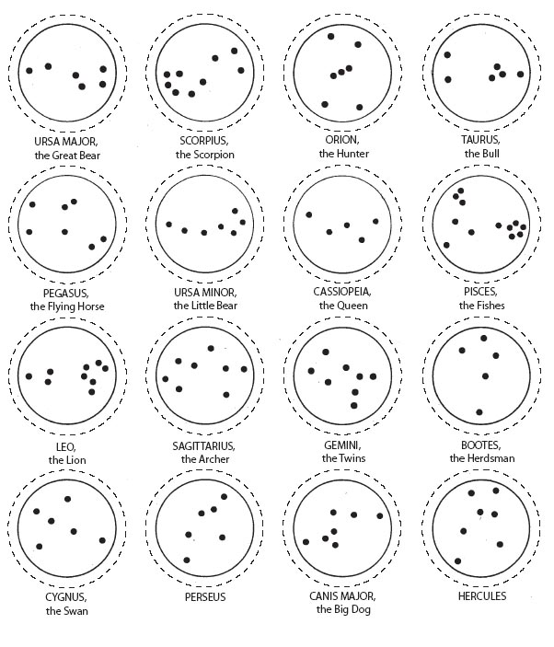
Appendix 5-Signalling
Morse code
Morse code is numbers or letters represented combinations of long and short sound or light signals.
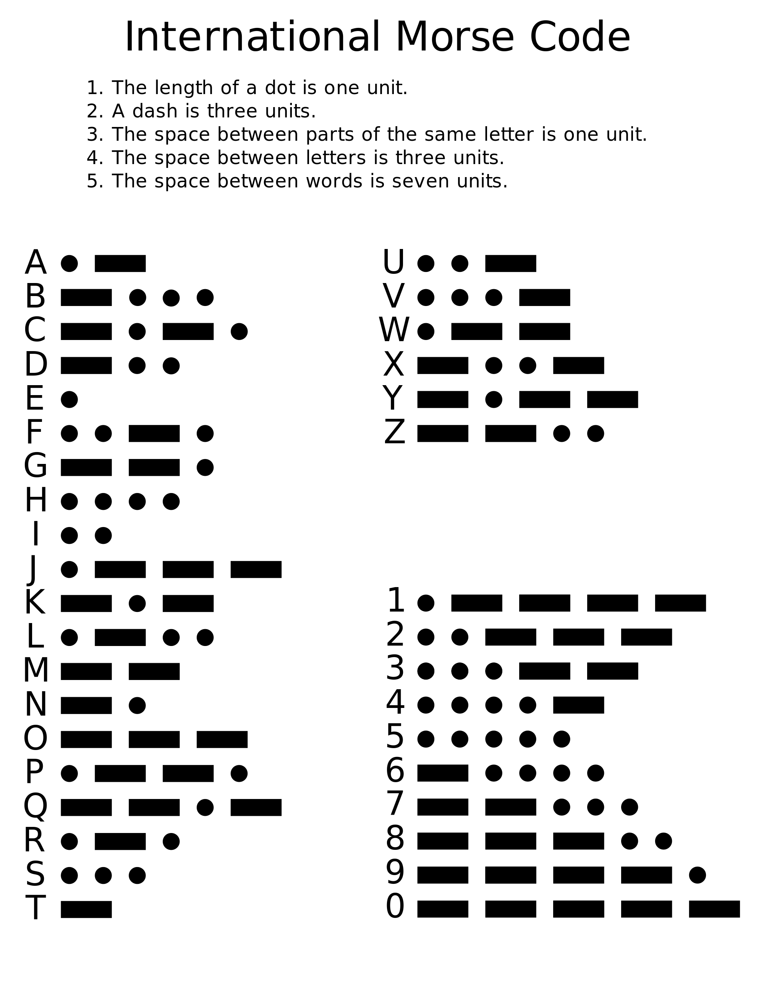

Semaphore
Signalling using flags to represent different letters
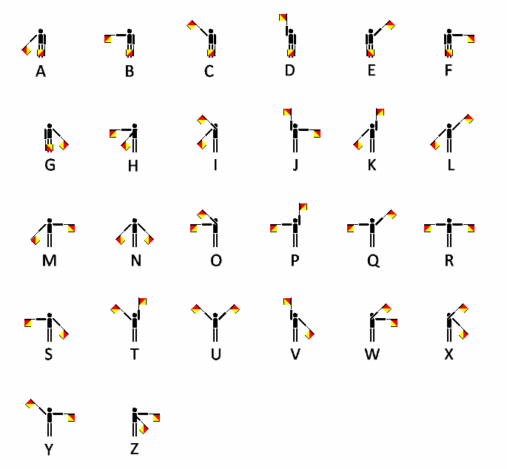
Appendix 6-Food health hygiene
Food health and hygiene quiz
Q1. What temperature should frozen food be kept at?
- -18 degrees or lower
- 0 degrees
- 15 degrees or lower
a. -18 degrees or lower

Q2. True or false: you must poultry and chicken before cooking?
False - only wash it if there is visual contamination such as dirt. Washing poultry causes the bacteria in the water drops to spread quicker.

Q3. How often can you reheat leftovers?
- As often as you like
- Twice
- Once
- Cannot reheat
Once - If food is reheated more than once there is an increased risk of food poisoning due to the bacteria in the food.

Q4. When you are preparing food how should you dry your hand?
- Damp cotton towel
- Paper towel
- Let them dry naturally
- Wipe them on your clothes
b. Paper towels - Paper towels absorb all the water and can easily be disposed off. If you let them dry naturally all the water from your hands might not be removed. A damp cotton towel is an environment, which can harbour bacteria. You don't know what germs are on your clothes and can also harbour bacteria.
Q5. True or false: If you stick to the “five seconds” rule you can still eat what has dropped to the floor?
False - No matter how quick you pick up food, which has dropped on the floor, it would have been in contact with germs.

Q6. True or false: if food is cooked on the outside does this mean it’s cooked on the inside?
False - although the surface may be cooked, the centre may not be. It is important to ensure that all food is thoroughly cooked all the way through.

Q7. True or false: can you eat food after the “best before” date?
True - “best before” dates are a guide to the quality of food. If you have food after the “best before” date, make sure it has not lose its colour, flavour or texture.

Q8. True or false: you need to wash copping boards and utensils after using them for raw meat?
True - Bacteria can transfer from the chopping boards and utensils. If you are using the chopping board and utensils for ready to eat food the bacteria will be transferred to the food. This is known as cross contamination.

Q9. Which of the following type of more hygienic to use?
- Plastic
- Wooden
- Neither
c. Neither; there is no scientific evidence to suggest one is more hygienic than the other. It is important to make sure the chopping board gets properly cleaned after each use. You should also use separate chopping boards for raw and ready-to-eat foods.

Q10. Which of the following is likely to contain the most bacteria?
- Opened fizzy drink
- Cooked chicken
- Frozen chicken
- Bottled tomato sauce

c. Frozen chicken

Confirmation of branding-From Girlguiding UK and SSAGO

